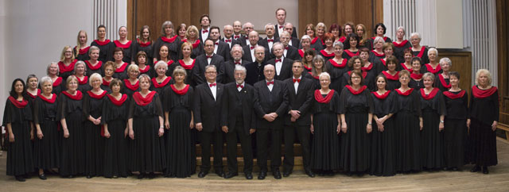

Berliner Oratorien-Chor
Founded in 1904 as „Berliner Volks-Chor” (Berlin People’s Choir), the Berliner Oratorien-Chor (Berlin Oratorio Choir) is a reliable performing body in the capital’s classical concert scene. The choir’s self-set task is to perform not just popular but also lesser known oratorios and other choral works through regular self-organized concerts at the Berliner Philharmonie and the Konzerthaus Berlin, as well as through cooperative projects or guest appearances. Between 1958 and 2008 the choir established itself in Berlin’s music scene under the direction of Gert Sell and received the Zelter Plaque in 2004 for its many years of work in and care for choral music. Thomas Hennig took over the musical direction of the choir in 2008. By way of innovatively arranged programs and high artistic claim, the choir remains a pioneering institution. The choir consists of around 80 active singers of diverse backgrounds and multiple generations.

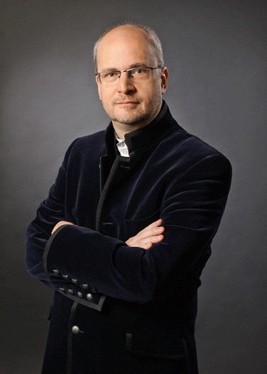
Thomas Hennig
Thomas Hennig was born in Hanover, Germany, where he also began his studies which he later continued in Osnabrück. Initially, he was primarily active in Brandenburg an der Havel as choir and music director at the local theatre, but soon gained international recognition. For two years he conducted the choir and orchestra of the Antalya State Opera in Turkey. Since 2005 he has been teaching at the Universität der Künste Berlin (Berlin University of the Arts) and since 2014 he also heads the department for conducting at the Paul Hindemith School of Music in Berlin-Neukölln. He not only directs the Berliner Oratorien-Chor but also the Singakademie Potsdam and the Concentus Neukölln chamber choir, is chief conductor of the Neue Preußische Philharmonie and regular guest conductor of the Berliner Symphoniker. His international activities recently led him to Ulan Bator in 2019 where, during a gala concert representing the German music tradition, he was honored to be the first German conductor to ever direct a concert in Mongolia.

